SIMATS ENGINEERING

ASSESSMENT TOOL 1

COURSE NAME: Database Management Systems

COURSE CODE: CSA05

NAME:G.CHAKRADHAR
REGNO:192311439

1. DDL (Data Definition Language) - CREATE, ALTER, DROP

Simplified Explanation:
DDL commands build the "skeleton" or empty containers of your database. You aren't playing with data yet; you are just creating the structures to hold it.

Real-Life Example:
Think of constructing a house. CREATE is laying the foundation and building rooms. ALTER is breaking a wall to add a new window later. DROP is bringing a bulldozer to demolish the whole house.

Example Table (House_Rooms):
Room_ID | Room_Type | Square_Feet
1 | Kitchen | 250
2 | Living Room | 400

ER Diagram:
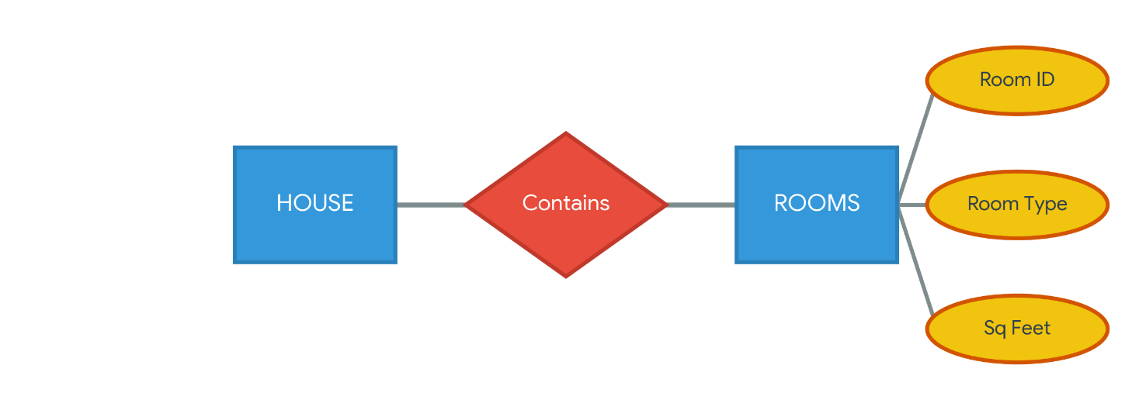

2. Constraints (PRIMARY KEY, FOREIGN KEY, CHECK)

Simplified Explanation:
Constraints are strict rules applied to your data containers. Primary Key ensures everyone is unique. Foreign Key connects one table's data to another table. Check ensures data makes logical sense.

Real-Life Example:
Your Fingerprint is your Primary Key (nobody else has it). Your Passport linking you to your home country is a Foreign Key. A rule that says "Age must be over 18 to enter a club" is a Check Constraint.

Example Table (Citizens & Countries):
Citizen_ID (Primary Key) | Name | Age (Check > 18) | Country_Code (Foreign Key)
C-101 | John Doe | 25 | US
C-102 | Priya Sharma | 30 | IN

ER Diagram:
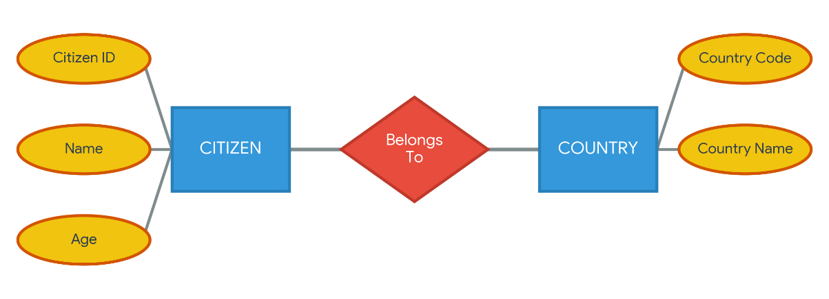

3. DML (Data Manipulation Language) - INSERT, SELECT, UPDATE, DELETE

Simplified Explanation:
Once your containers are built, DML commands are how you actually interact with the data inside them.

Real-Life Example:
Using a digital contact book on your phone: Saving a new friend's number is INSERT. Searching for their name to call them is SELECT. Changing their number when they get a new phone is UPDATE. Deleting them after a fight is DELETE.

Example Table (Phone_Contacts):
Contact_ID | Name | Phone_Number | Status
1 | Alice | 555-0101 | Active (UPDATED)
2 | Bob | 555-0202 | Blocked

ER Diagram:
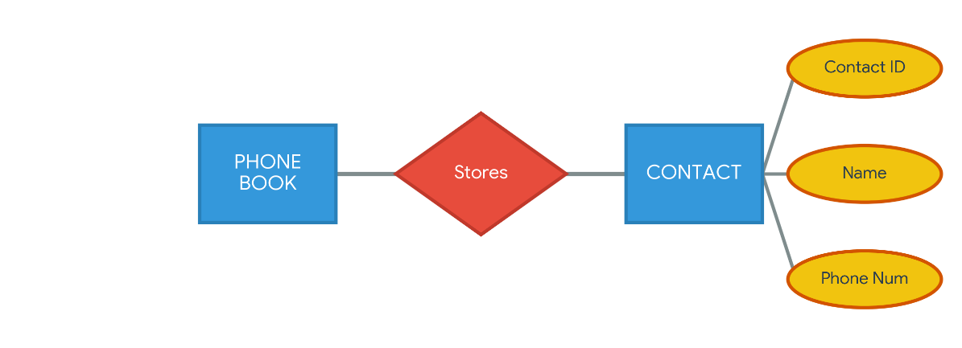

4. Data Filtering (WHERE, LIKE, BETWEEN, GROUP BY)

Simplified Explanation:
These commands are powerful search filters to find exactly what you want from massive amounts of data.

Real-Life Example:
Going to a massive supermarket and telling the assistant: "Show me all snacks (WHERE) that taste like chocolate (LIKE), cost between $2 and $5 (BETWEEN), grouped by their brand name (GROUP BY)."

Example Table (Supermarket_Snacks):
Snack_ID | Item_Name | Flavor | Price | Brand
101 | Choco-Bites | Chocolate | $3.50 | SweetCorp
102 | Choco-Chip Cookie | Chocolate | $4.00 | SweetCorp
103 | Potato Chips | Salty | $2.50 | SaltySnacks

ER Diagram:
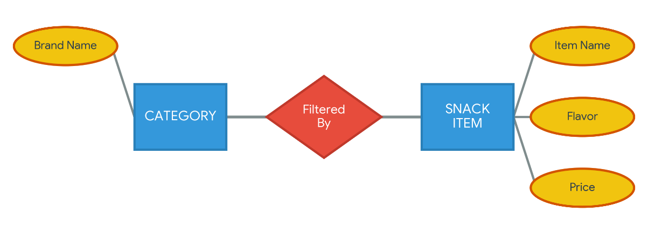

5. Joins (Combining Tables)

Simplified Explanation:
Joins stitch two different tables together by finding a matching column between them.

Real-Life Example:
A restaurant waiter holds your Order Ticket (Table 1), and looks at the Kitchen Menu (Table 2). He Joins them together in his head by matching the "Dish Number" to calculate your final bill.

Example Table (Combined View of Order + Menu):
Table_No (From Order) | Dish_ID (Match Key) | Dish_Name (From Menu) | Price (From Menu)
Table 4 | D-05 | Spaghetti | $12.00
Table 4 | D-08 | Garlic Bread | $4.00

ER Diagram:
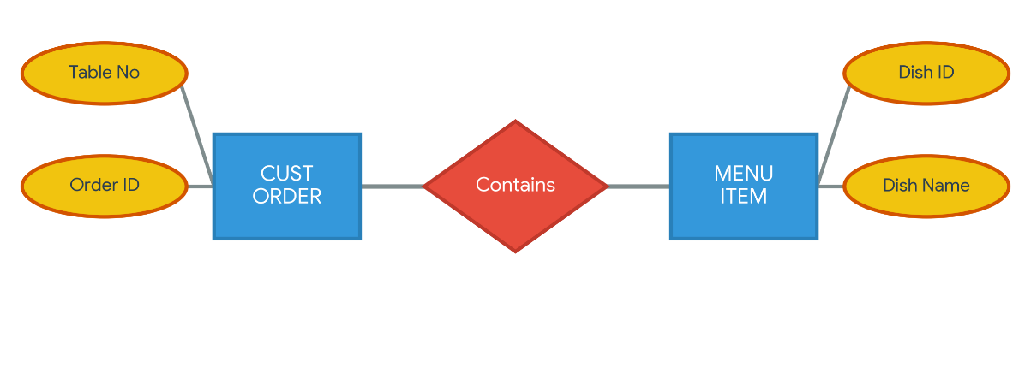

6. Views and Indexes

Simplified Explanation:
A View is a virtual table (a saved search) so you don't have to write a long query every time. An Index is a background tool to make searching lightning fast.

Real-Life Example:
A View is like creating a "Favorites" playlist on Spotify; the songs aren't copied, they are just viewed through a specific lens. An Index is like the glossary at the back of a 1000-page textbook allowing you to find a word instantly without reading every page.

Example Table (Playlist_View):
Song_ID (Indexed) | Song_Name | Artist
S-88 | Shape of You | Ed Sheeran
S-92 | Blinding Lights | The Weeknd

ER Diagram:
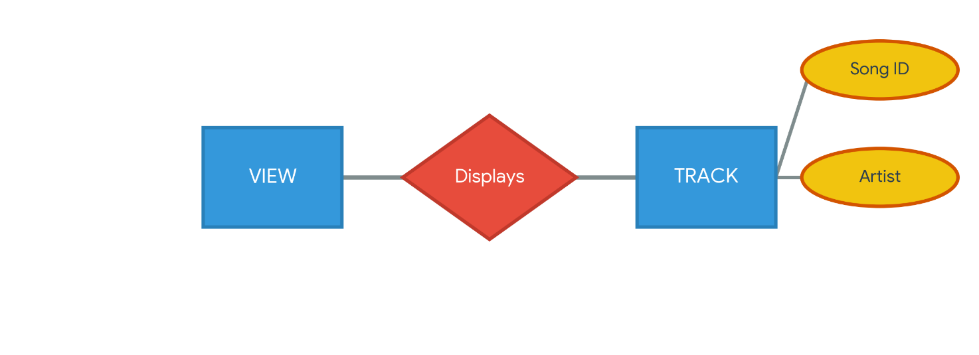

7. TCL (Transaction Control Language) - COMMIT, ROLLBACK

Simplified Explanation:
TCL commands manage tasks that have multiple steps. If all steps succeed, you save it permanently. If one step fails, you undo everything to keep data safe.

Real-Life Example:
Playing a difficult video game. You reach a safe room and save your game (SAVEPOINT). You beat the final boss and finish the game (COMMIT). You die trying to jump over a pit, so you restart from your last save (ROLLBACK).

Example Table (Bank_Transfer_Log):
Transaction_ID | Sender | Receiver | Amount | Status
TXN-001 | John | Alice | $500 | Committed (Success)
TXN-002 | Bob | Eve | $9999 | Rolled Back (Failed)

ER Diagram:
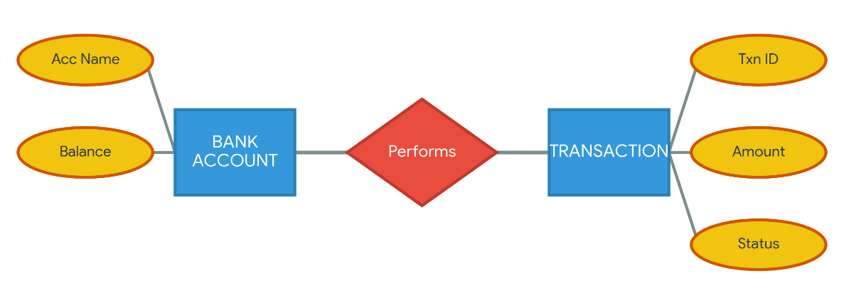

8. DCL (Data Control Language) - GRANT, REVOKE

Simplified Explanation:
DCL commands act as the security guards of the database, giving or taking away permissions from users.

Real-Life Example:
Giving a spare key to your neighbor to feed your cat while you are on vacation (GRANT). Asking for the key back the moment you return home (REVOKE).

Example Table (Security_Access):
User_Name | Role | Permissions
Admin_Sarah | Manager | Granted (ALL)
Temp_Intern | Guest | Revoked (Delete Access)

ER Diagram:
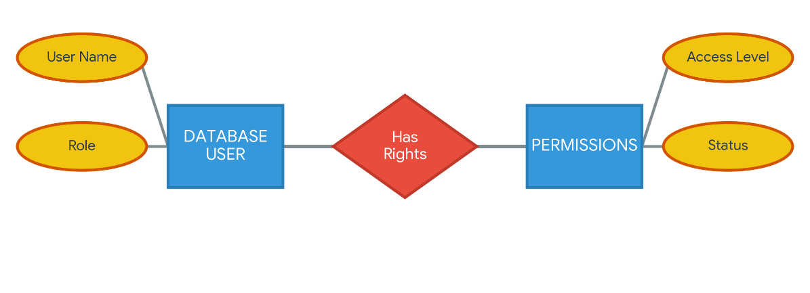

9. Procedures and Functions

Simplified Explanation:
Both are saved blocks of code. A Function must calculate and return a single answer. A Procedure just performs a set of actions without necessarily answering you back.

Real-Life Example:
A Function is a thermometer (You put it in, it calculates, and returns exactly "98.6 degrees"). A Procedure is a washing machine (You press start, it washes, rinses, spins, and turns off, returning nothing).

Example Table (Automated_Tasks):
Task_Name | Type | Input | Result/Action
Calculate_Tax | Function | $1000 | Returns $150
Send_Emails | Procedure | User List | Sends 500 emails (No return)

ER Diagram:
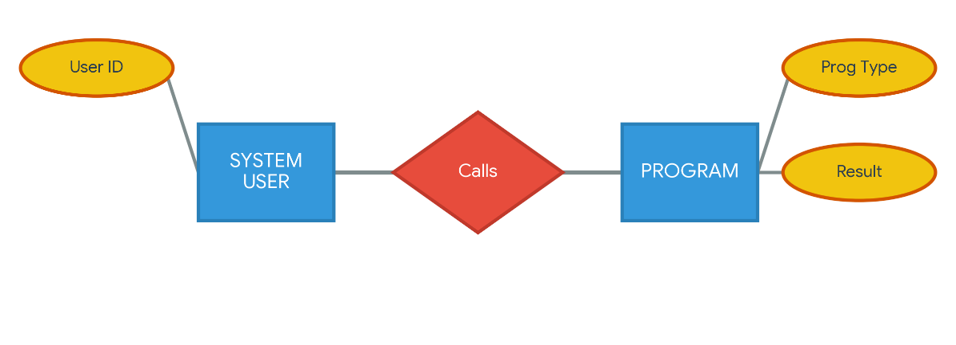

10. Cursors & Triggers

Simplified Explanation:
A Cursor processes data slowly, one single row at a time. A Trigger is a booby-trap that automatically runs code when something specific happens in the table.

Real-Life Example:
A Cursor is a bouncer at a club checking ID cards one person at a time in a line. A Trigger is a motion-sensor security light that automatically turns on the second someone steps on the lawn.

Example Table (Security_Logs via Trigger):
Log_ID | Event_Caused_By | Action_Taken_Automatically | Time
991 | User updated salary | Log saved to audit table | 10:45 AM
992 | User deleted record | Backup created | 11:02 AM

ER Diagram:
